Sep 26, 2026

Little Rock AI & LLM

Summary
Community session covered AI industry updates, tokenization fundamentals, and agent optimization strategies.
Industry News And Frameworks
Updates covered Anthropic and OpenAI model releases alongside China strategy and new decision frameworks.
Tokenization Fundamentals And Economics
Discussion detailed the end-to-end token journey, vocabulary sizing, and API pricing models.
Agent Optimization And Closing
Participants explored reducing agent token consumption, managing prompt lengths, and community resources.

Next steps
- [The group] Fix QR Code: Correct the QR code for attendee check-in before the upcoming session.
- [The group] Review Tokenization Libraries: Examine the tiktoken and Hugging Face tokenizer libraries to understand Byte Pair Encoding implementation.
- [The group] Test Tokenization API: Verify the Claude token counting API to calculate token costs for model queries.
- [Olanrewaju Oyinbooke] Develop custom model: Post-train a small, tool-calling model using personal coding datasets to achieve specific project goals.
- [Olanrewaju Oyinbooke] Publish findings: Document and share findings and lessons learned from the model development process.
- [The group] Write project updates: Write a medium post or share small-scale project experiences to encourage community learning.
- [Bolaji BALOGOUN] Share Resources: Distribute the full PDF presentation to the group. Allow participants to access the practical segments for individual review.
- [Bolaji BALOGOUN] Organize GitHub: Transfer previous project artifacts into the community repository. Structure these assets for improved navigation.
- [Bolaji BALOGOUN] Update Agenda: Insert a 15-minute Q and A session into the schedule for the upcoming meeting. Prepare to address any lingering questions from the current session.

Details
- Meeting Link Issues and Resolution: Bolaji BALOGOUN identified an issue that the meeting link sent via email was incorrect and placed participants into a waiting room instead of the recurring meeting (00:00:02). After checking their calendar links and statuses, Bolaji BALOGOUN cancelled the previous invitation and sent a new Google Meet invite, allowing Ridwan Amure and Olanrewaju Oyinbooke to successfully join the call (00:03:24).
- Community Meeting Structure and Objectives: Bolaji BALOGOUN introduced the second session of the "Behind the Scene" series, which focuses on understanding what happens beneath the hood of large language models compared to the first series of building directly with artificial intelligence (00:11:45). Bolaji BALOGOUN outlined their community's core pillars of connecting local and online builders in Little Rock, learning through shared trends and plain-language explanations, building practical projects, and growing professional skills (00:13:16). Furthermore, Bolaji BALOGOUN detailed the meeting agenda, which included industry news, a two-part technical session on tokens led by Ridwan Amure, a 10-minute break, a four-versus-against debate, and a general question-and-answer session (00:16:01).
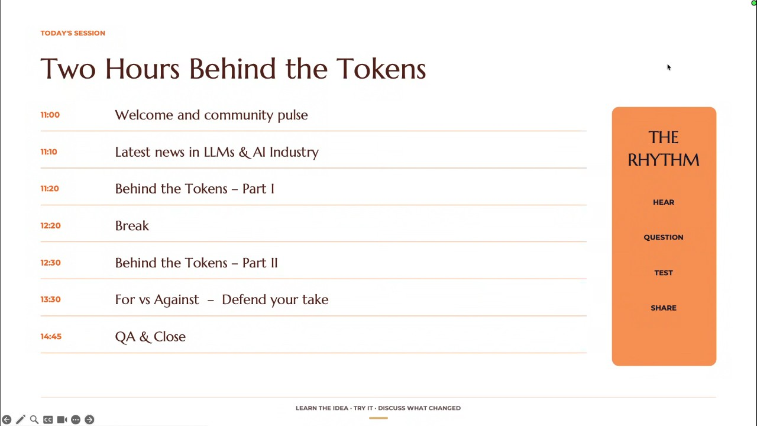
- Industry News - Frontier Capabilities, Agents, and Scientific Research: Bolaji BALOGOUN presented recent artificial intelligence industry news, highlighting five major trends over the preceding two weeks (00:17:31). Bolaji BALOGOUN noted that Anthropic released Opus 5.5, which delivers performance close to Travel 5.1 while costing 40% less and running faster (00:21:37). Additionally, OpenAI and Meta are pushing agents as commercial interfaces, with OpenAI testing business-sponsored agent conversations and Meta integrating coding agents into a single build platform. Bolaji BALOGOUN also mentioned that artificial intelligence is accelerating scientific research, with Google research saving meaningful time and Anthropic identifying a novel enzyme system through code, though shifting the bottleneck to validation (00:23:18).
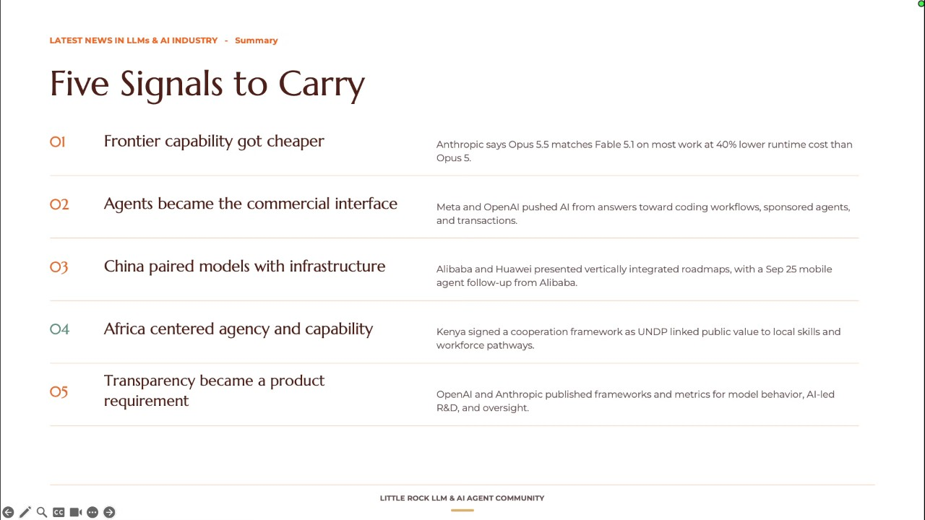
- Industry News - China's Full-Stack Approach, African Regional Context, and Transparency: Continuing the industry news overview, Bolaji BALOGOUN discussed China's full-stack approach to artificial intelligence sovereignty, noting that Alibaba and Huawei are building coordinated systems connecting models, chips, clusters, cloud services, and mobile agents, including a partnership with Honor announced on September 25th (00:24:46). Regarding Africa, Bolaji BALOGOUN observed a lack of major frontier model launches, though Kenya signed a cooperation framework with Anthropic during a General Assembly side event, emphasizing institutional talent and local priorities (00:26:12). Finally, Bolaji BALOGOUN reported that transparency is becoming a product requirement, with OpenAI publishing misalignment reporting frameworks and Anthropic reporting that code led 26% of their research and development work in August, alongside government investments in Canada and Germany (00:28:10).
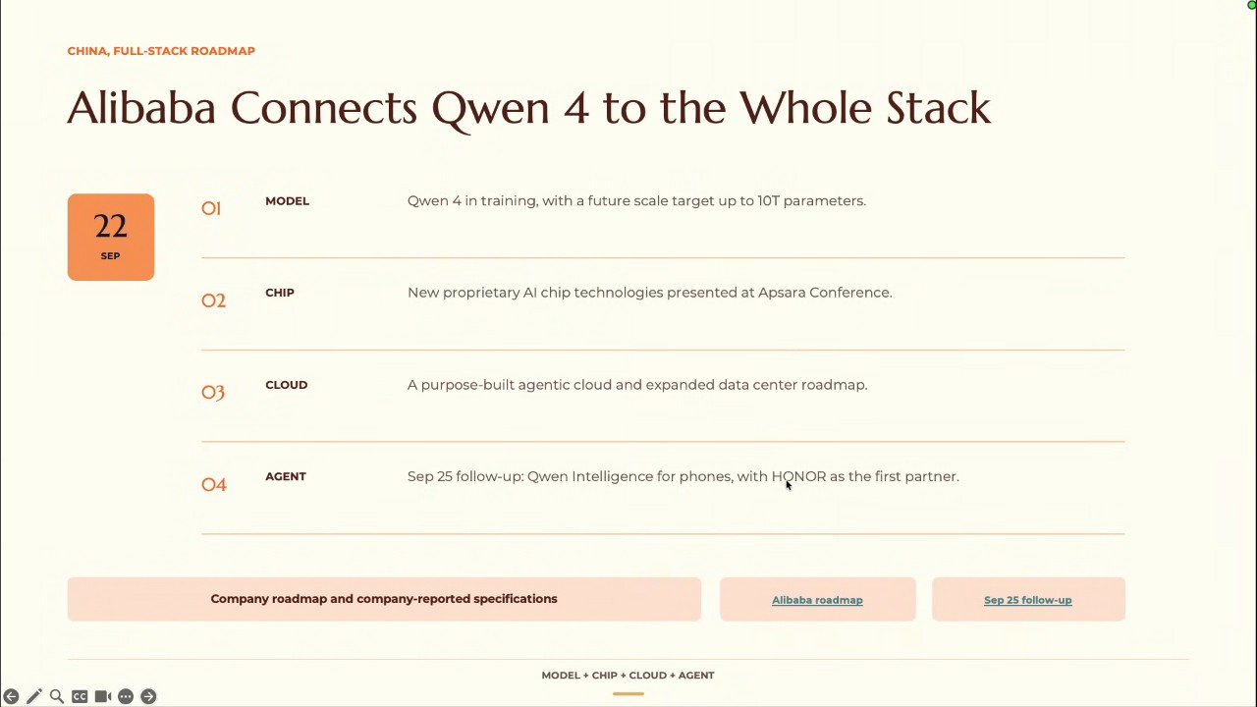
- Evaluation of the Jev Framework: Olanrewaju Oyinbooke introduced the new Jev framework, which outputs decisions and probabilities rather than generated text, making it useful for deterministic decision processes and reducing unreliability (00:29:53). Olanrewaju Oyinbooke noted that Google also released a Gemma diffusion Jev mode to achieve similar functionality (00:31:12). However, Ridwan Amure challenged this, arguing that Jev is more of a marketing scheme than a scientific breakthrough, as its underlying algorithms and engineering rely on recombining and scaling long-known software and key-value cache ideas rather than introducing new technical paradigms (00:32:28).
- Academic Publishing Standards and Evaluating Model Updates: Ridwan Amure discussed changes to International Conference on Learning Representations conference submission rules, noting that reviewer criticisms and rejection comments will be made public and attached to authors' names permanently, while demanding higher standards from researchers utilizing artificial intelligence tools for faster experimentation (00:36:25). Building on this, Ridwan Amure emphasized that professionals must separate marketing hype from genuine engineering breakthroughs to avoid constantly chasing new bandwagons (00:38:20). Consequently, Bolaji BALOGOUN and Ridwan Amure discussed the need to evaluate whether to adopt new models like Opus 5.5 or explore Chinese models based on specific accuracy, cost, and infrastructure requirements (00:39:29).
- Adoption of Chinese Models and Meta's Strategy: Olanrewaju Oyinbooke shared their experience using Chinese models such as GLM, Kimmy, and DeepSeek 4.1 flash integrated into Codex for routing requests, alongside Muse 1.3 (00:40:28). Shifting to Meta, Olanrewaju Oyinbooke and Ridwan Amure analyzed Meta's unexpected progress with their super intelligence lab, with Ridwan Amure explaining that Meta's primary goal is not to beat frontier coding models, but to place practical artificial intelligence productivity tools into the hands of regular creators on Instagram and business owners (00:41:29). Furthermore, Ridwan Amure contrasted this commercial focus with Google DeepMind, describing DeepMind as a scientific research brain focused on long-term breakthroughs like transformers rather than being a twenty-four-seven commercial language model provider like Anthropic or OpenAI (00:44:27) (00:46:20).
- Google's Search Monetization Bottleneck and Meta's Pivot: Olanrewaju Oyinbooke argued that Google's primary bottleneck is protecting its existing search monetization stream, making them extra careful with product releases compared to competitors willing to disrupt them (00:47:26). Ridwan Amure noted that while Google historically handles competing internal products on platforms like Google Cloud Platform, companies like Meta have had to pivot toward engineering and productivity to capture market share (00:48:39). Following these discussions, Bolaji BALOGOUN transitioned the meeting to the technical session on tokens (00:49:39).
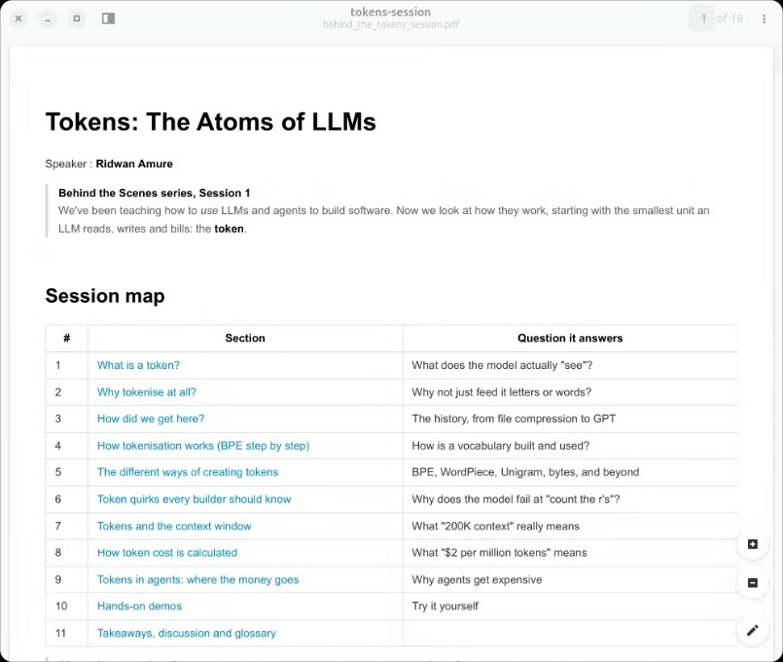
- Introduction to Tokenization Fundamentals: Ridwan Amure led the technical presentation on tokens, defining a token as the simplest subunit of a word or data piece that a language model processes, which can be a character, word, or part of a word (00:52:00). Ridwan Amure explained that because neural networks and machine learning models only understand numbers rather than natural language, tokenization converts words into deterministic integer IDs using models like the CL 100,000 base model tokenizer (00:53:27) (00:57:49). Additionally, Ridwan Amure noted that common root words are kept whole while prefixes and suffixes are split, providing a foundation for how language models transform raw text into numerical representations for training and pricing (00:54:46).
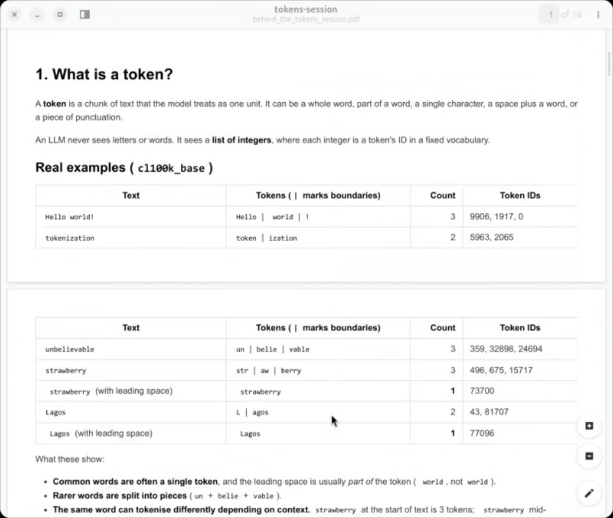
- Token Journey in Large Language Models: Ridwan Amure explained the end-to-end journey of a prompt in a large language model, detailing how a prompt like hello world is split by a tokenizer into integer token IDs (such as 9906 for hello, 917 for world, and 0 for exclamation mark) (00:58:56). Ridwan Amure noted that these IDs look up a model embedding table containing floating-point numbers representing semantic relationships, which then pass through transformer layers to predict subsequent tokens autoregressively (00:59:53). Ridwan Amure also highlighted that computer RAM limitations or streaming errors can expose backend token processing bugs (01:04:59).
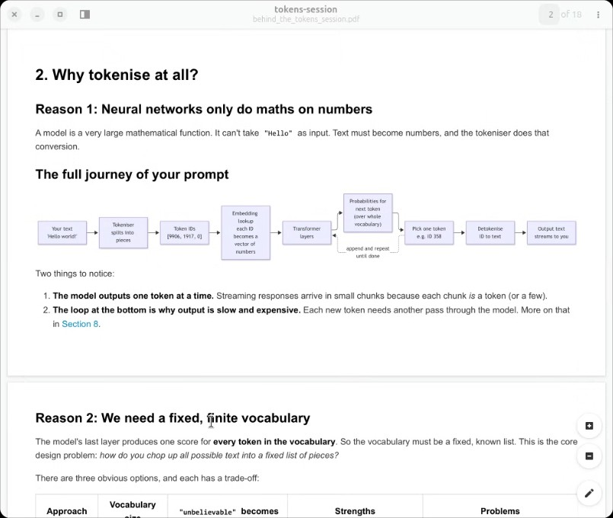
- Vocabulary Size and Historical Text Representation: Ridwan Amure discussed the necessity of maintaining a fixed, finite vocabulary list to prevent memory bloat and model memorization challenges (01:04:59). Ridwan Amure reviewed past approaches, including using individual characters (which resulted in sequences that were too long and unable to handle unknown words) and whole dictionary words (which frequently produced unknown tokens when words were missing from the training corpus) (01:06:16). Ridwan Amure explained that subword tokenization solved these issues by enabling compression and recombination without increasing computational requirements (01:07:25).
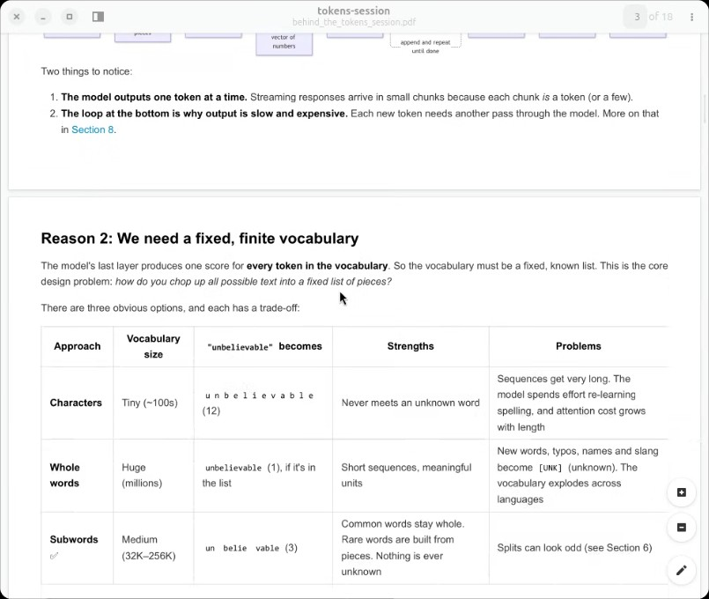
- History of Tokenization and Scientific Research: Ridwan Amure presented a historical overview of tokenization milestones, starting with Philip Gage inventing Byte Pair Encoding as a data compression tree in 1994, followed by Google adopting wordpieces for Japanese and Korean voice in 2012, Word2Vec in 2013, neural machine translation subwords in 2016, and advancing through Generative Pre-trained Transformer 2, T5, K9, Generative Pre-trained Transformer 4, Llama, and Llama 3 reaching 128k tokens in 2024 (01:08:38). Ridwan Amure emphasized that scientific research should focus on contributing foundational knowledge rather than immediate commercial outcomes, citing Kullback-Leibler divergence from 1965 or 1975 as another example of a historical metric finding vital use in post-training for large language models (01:13:24).
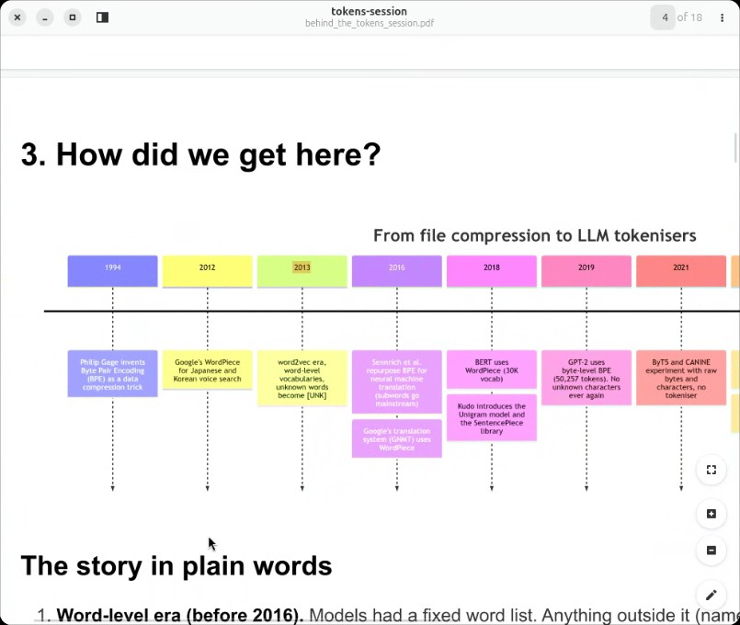
- Masterclass Pace and Structure Feedback: Following a checkpoint inquiry by Ridwan Amure regarding whether to take a break or continue as a marathon, Bolaji BALOGOUN and Olanrewaju Oyinbooke evaluated the session. Olanrewaju Oyinbooke expressed that the 18-minute pace was ideal, establishing essential fundamentals and historical context, while Bolaji BALOGOUN agreed that the pacing was appropriate and left the decision to Ridwan Amure, ultimately leading the group to continue (01:14:35).
- Economics and Pricing of Tokens: Olanrewaju Oyinbooke raised a question regarding why tokens were chosen as the new currency and pricing mechanism for large language model application programming interfaces (01:17:07). Ridwan Amure explained that token pricing correlated strongly with floating-point operations per million tokens and provided a transparent, visible metric for consumers compared to older per-request or subscription models, though acknowledging that tokenization can introduce arbitrary splits and hidden profit margins for providers like Anthropic (01:18:13).
- Tokenizer Training and Corpus Definition: Ridwan Amure detailed how tokenizers are trained using a large text corpus, defining a corpus as a collection of available words or data in an experiment (01:22:50). Ridwan Amure explained the training phase where text is split into characters, adjacent pairs are counted in a loop, and the most frequent pairs are iteratively merged into new tokens until reaching a predetermined vocabulary limit such as 100k tokens (01:26:22).
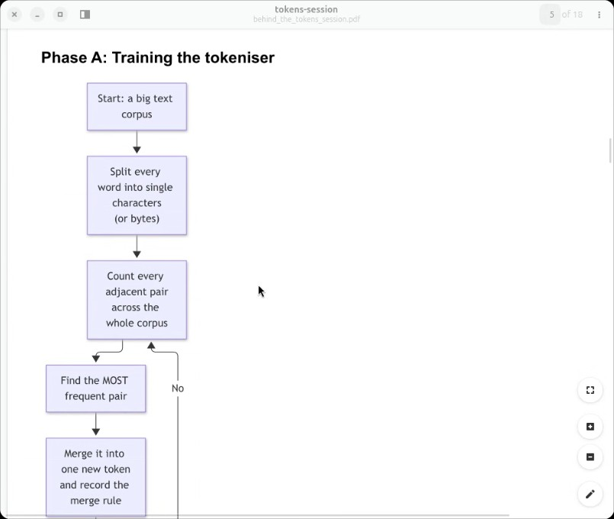
- Byte Pair Encoding Subword Example: Ridwan Amure demonstrated Byte Pair Encoding using a small corpus containing words like low, lower, newest, and widest with frequency counts, showing how suffixes like est and base words like new or low are iteratively merged (01:27:34). Ridwan Amure explained that while subwords reduce vocabulary size, words split into multiple tokens incur higher token charges, though newer models with expanded vocabularies can represent compound words in fewer tokens (01:30:06).
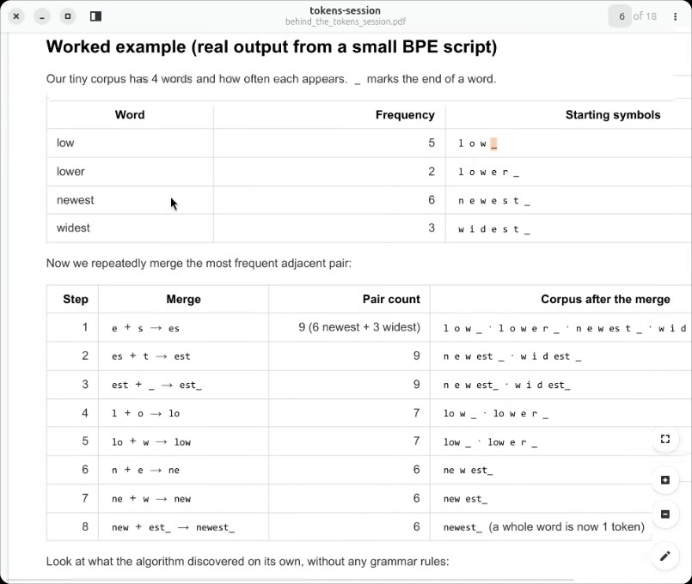
- Detokenization and Special Tokens: Ridwan Amure described the backend process of detokenization, where models output token sequences that must be reconstructed into readable text, noting strategies like using pound signs in models like Bidirectional Encoder Representations from Transformers to indicate tokens that should be joined together (01:32:32). Ridwan Amure noted that production tokenizers incorporate additional pre-processing steps and special tokens for sentence boundaries, part of speech, system roles, and agent tools (01:34:56).
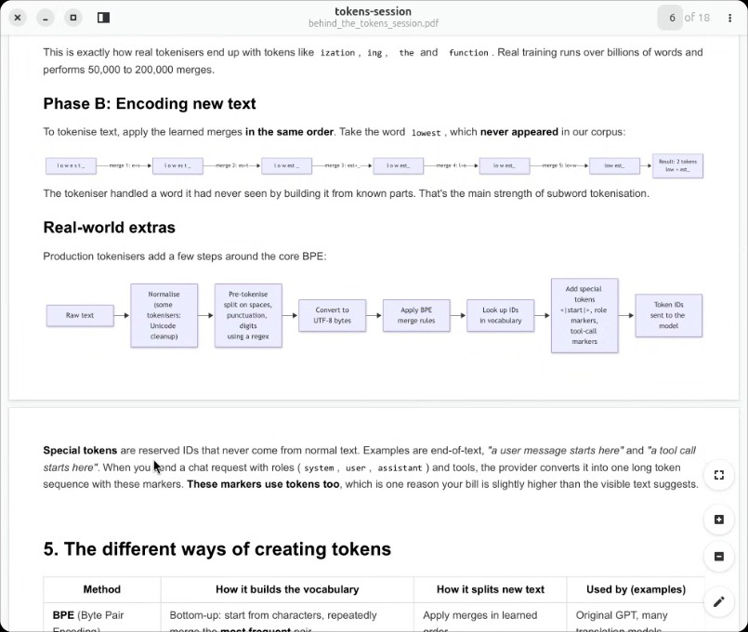
- Practical Tokenization Implications for Users: Ridwan Amure advised users on practical limitations and token consumption behaviors, noting that character-level spelling shortcuts do not reduce token counts because models evaluate token IDs rather than spelling (01:37:32). Ridwan Amure highlighted that numbers consume tokens rapidly by splitting into separate chunks, and English text offers significantly higher token efficiency compared to other languages like Yoruba, while emojis, white space, and capitalization also impact token counts (01:38:53).
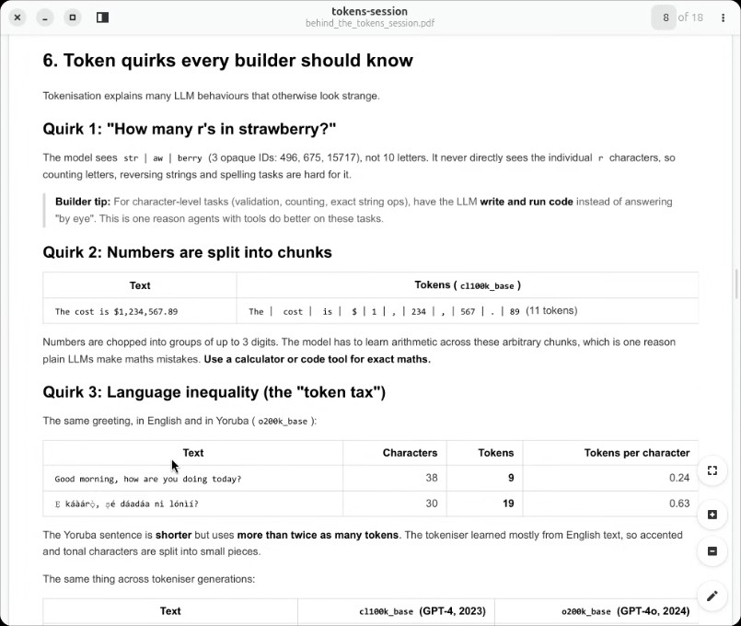
- Context Window Limits and Cost Calculation: Ridwan Amure clarified that an application programming interface context window limit encompasses both input tokens and model output tokens combined, rather than input alone (01:41:51). Ridwan Amure explained that output tokens include hidden reasoning and thinking steps generated by reasoning models, and provided the formula for calculating total costs based on input token volume divided by 1 million input price plus output token volume divided by 1 million output price (01:43:19).
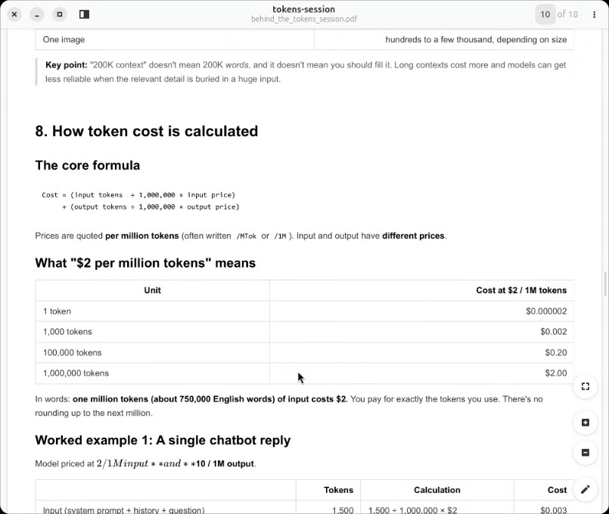
- Query on Token Repetition and Stop Words: Bolaji BALOGOUN asked whether repeated tokens in chatbot instructions incur duplicate charges or unique charges, to which Ridwan Amure responded that all duplicate tokens are maintained and billed because order is critical for model comprehension (01:45:33). Ridwan Amure suggested that engineering teams could reduce costs by removing stop words that do not alter sentence meaning, though Peter Zokoro and Bolaji BALOGOUN discussed the engineering trade-offs and effectiveness of implementing intermediate layers for stop word removal (01:47:47).
- Output Token Cost Disparities and Hidden Expenses: Ridwan Amure explained why output tokens cost more than input tokens, noting that inputs are processed in parallel in one efficient pass, whereas outputs are generated sequentially where each newly generated token is fed back as an input for the next token step (01:49:58). Ridwan Amure added that hidden expenses arise from repeated system prompt re-reading, tool definitions, conversation history length, images, and PDFs, while cost reduction strategies include prompt caching, batch application programming interfaces, smaller models, and shuttered outputs (01:53:55).
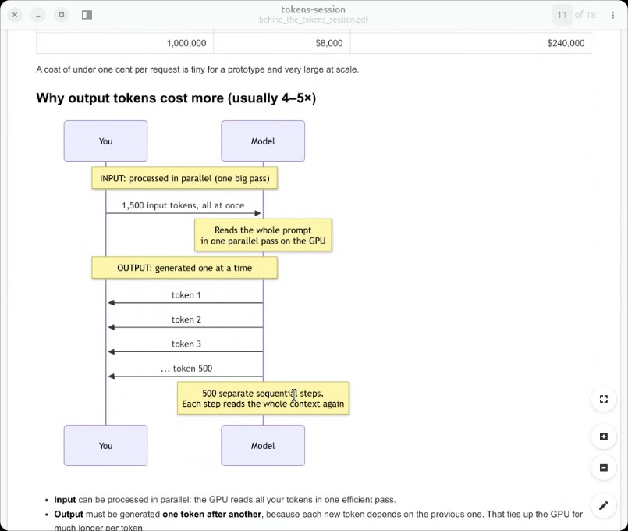
- Agent Loop Token Consumption: Ridwan Amure explained how autonomous agent loops consume tokens rapidly as conversation history accumulates across multiple turns. Ridwan Amure detailed an example where initial system prompts and user inputs combine with tool definitions, file reads, and tool execution results, causing input token volume to compound with each subsequent turn in the agent execution loop (01:56:42).
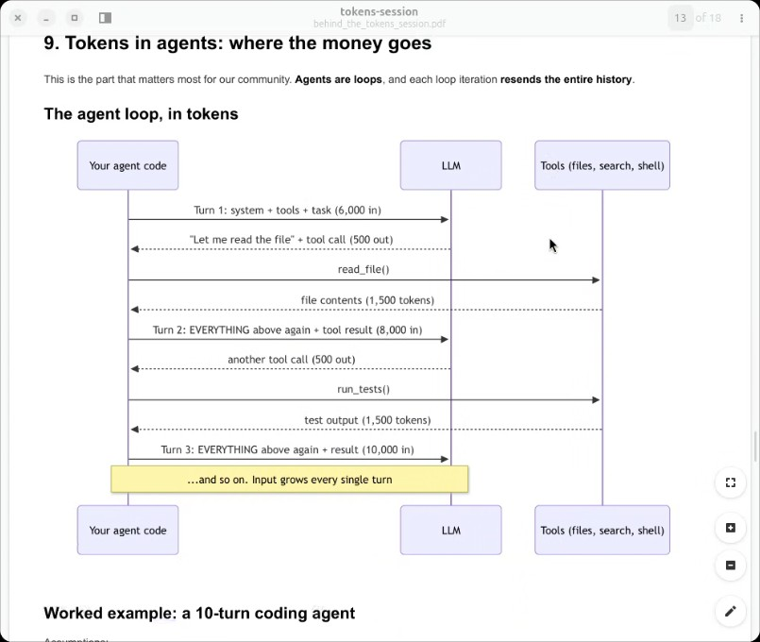
- Token Budgeting and Vocabulary Size Trade-Offs: Ridwan Amure and Bolaji BALOGOUN discussed why a provider might choose a 200k vocabulary over a 32k vocabulary (01:57:52). Ridwan Amure explained that a larger 200k vocabulary makes products more affordable and allows providers to charge fewer tokens, though the underlying model requires a larger GPU, more embedding space, and consumes more computational resources to handle that space (01:59:22). Peter Zokoro also raised a question regarding how to budget tokens when building a customer support bot for Nigerian users in Pidgin and Yoruba (02:00:45).
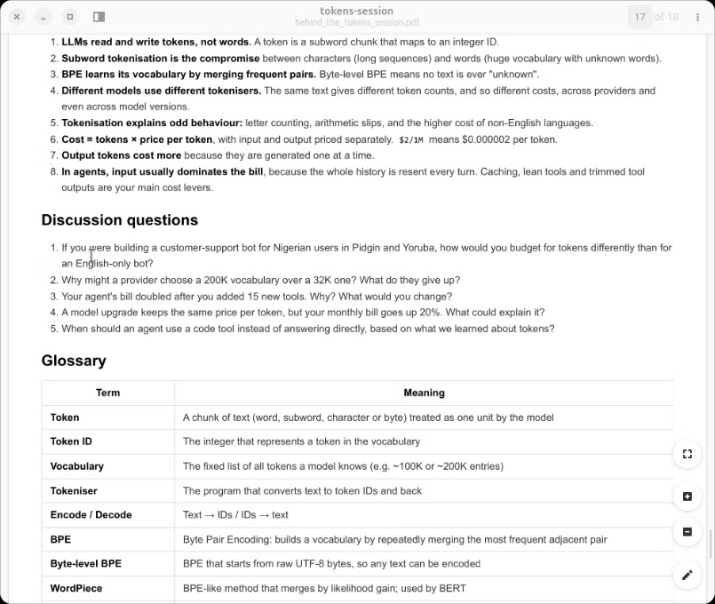
- Agent Prompt Length and Context Management: Peter Zokoro asked for recommendations on prompt length, noting that extensive context—such as recording 10-minute voice memos as prompts—yields better solutions from agents, but raises cost concerns (02:02:15). Ridwan Amure recommended that users be concise, draft and summarize content beforehand, and break down tasks rather than giving massive instructions all at once, noting that lengthy unorganized voice recordings are not saved efficiently and make validation difficult (02:03:28).
- Pidgin Language Tokenization and Translation Challenges: Peter Zokoro and Ridwan Amure explored why Pidgin might consume more tokens despite having fewer characters, noting that sparse corpus availability affects tokenization (02:06:46). Ridwan Amure suggested an alternative approach of using a small model to translate Pidgin to English before sending it to a larger model, and having the response returned in Pidgin. However, Ridwan Amure cautioned that this requires careful testing because errors can cascade if the initial translation mixes up context (02:07:58).
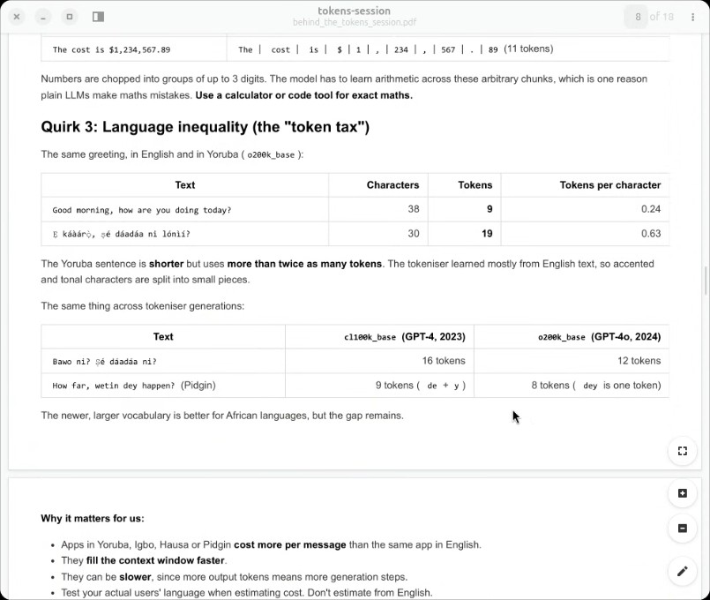
- Agent Tool Usage and API Optimization: Bolaji BALOGOUN noted that agent bills double after adding multiple tools because sequential tool calls repeat previous work and consume more tokens. Ridwan Amure provided an engineering perspective on optimizing API and file search tools—such as clearly mapping file directories or using layout extraction tools instead of forcing agents to scan the entire system repeatedly—and implementing rate limits to prevent endless error loops (02:09:12).
- Monthly Bill Increases and Model Upgrades: Ridwan Amure addressed why a monthly bill might increase by 20% despite a model upgrade keeping the same price per token (02:13:30). Bolaji BALOGOUN suggested that more powerful models consume more resources and shift computing costs to users (02:15:02). Ridwan Amure explained that increases can stem from higher customer volume, more requests, or more intermediate reasoning steps (such as OpenAI's o1 model consuming more tokens due to internal reasoning and precautionary verifications), which lead to exponentially higher costs when previous iterations are repeated (02:16:13).
- Personal Implementation and Code Caching Strategies: Peter Zokoro asked how to control agent behavior and tool usage on a personal implementation level using platforms like Claude or Codex (02:20:05). Ridwan Amure advised being intentional, setting bounded rules rather than giving absolute free reign, caching responses, and maintaining instruction files such as `claude.md` or `codex.md` (02:21:18). Furthermore, Ridwan Amure recommended saving reusable code scripts—such as a `plot.py` file for data visualizations—so agents update existing scripts instead of writing new visualization code from scratch and incurring duplicate token costs (02:22:53).
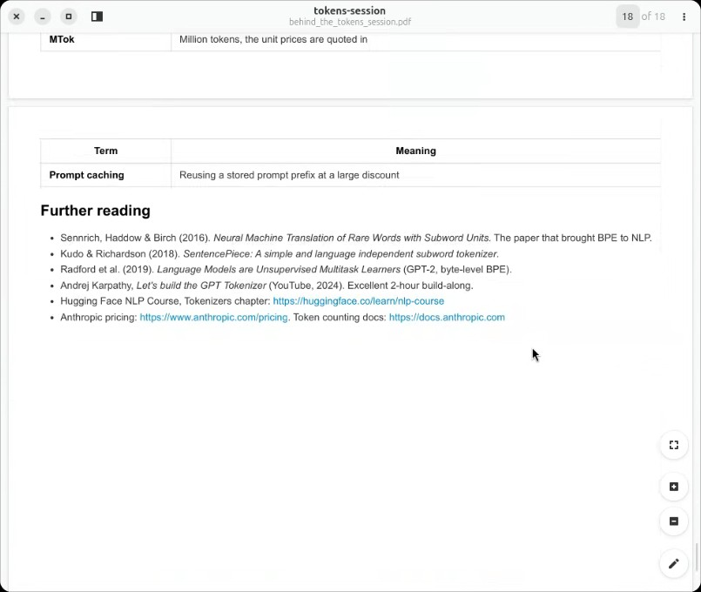
- Concluding Remarks and Practical Learning Recommendations: Olanrewaju Oyinbooke delivered closing remarks praising Ridwan Amure's presentation, inviting participants to download the Mitumo mobile app from the Google Play Store or Apple Store to join the community, and encouraging practical building (02:25:41) (02:32:57). Olanrewaju Oyinbooke recommended watching Andrej Karpathy's 2-hour build-along video on building a GPT tokenizer, shared a personal story about starting with Python and natural language processing in 2016, and emphasized that personal grit and commitment are essential to turning knowledge into skill (02:26:53) (02:29:21).
- Community Resources and Next Meeting Agenda: Bolaji BALOGOUN thanked Ridwan Amure, shared a community GitHub organization link (`github.com/ai`) where previous assets and artifacts will be organized, and proposed adding a 15-minute review session to the next meeting's agenda so participants can ask questions about the materials and discuss any unresolved parts of the video (02:34:02).

